Glue Lab 3
Step 1: create buckets
Step 2: create and configure glue pipeline:
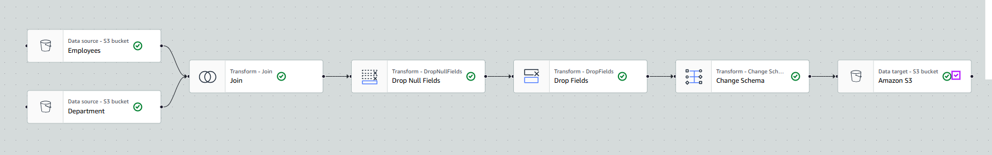
Step 3. Run and check output
